# Walta-logo.jpg

# Little WALTA Style guide / Workflow

General

**Font:**  Tahoma or screen readable san serif equivalent

**Background colour:** white #ffffff

**Blue:** #2f61cc

**Gradient:**  blue (#2f61cc ) to white (#ffffff)

Anchor Bar



Stays on screen throughout whole app while in landscape mode.

1. Home button - takes you back to home screen from anywhere in app.
2. Top anchor bar - blue gradient (#2f61cc to #ffffff).
3. Section heading - Top level name of section stays throughout whole section. Font: Tahoma, centered.
4. Settings button. Takes you to setup & contact info.
5. Help/info button. Takes you to same section as "help" button on home screen.

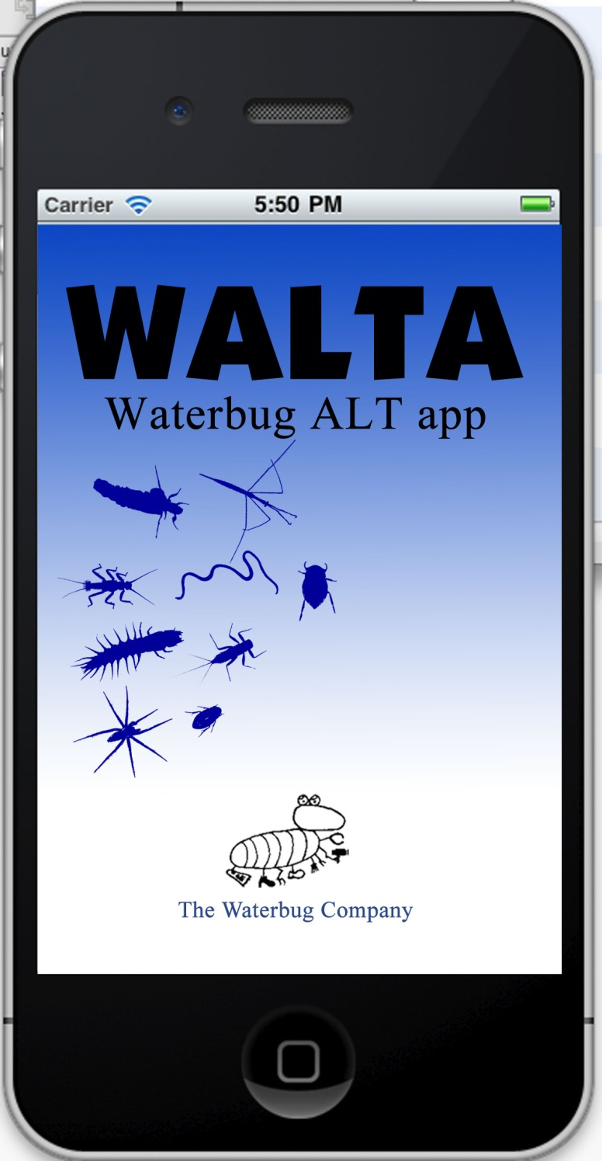Launch screen

**Description:** Screen that launches at startup, remains for about 2-3 seconds, then moves on to home screen. No links or hot sections needed.

Home screen

**Description:** Main screen for the app. This is the screen that the home button goes back to.

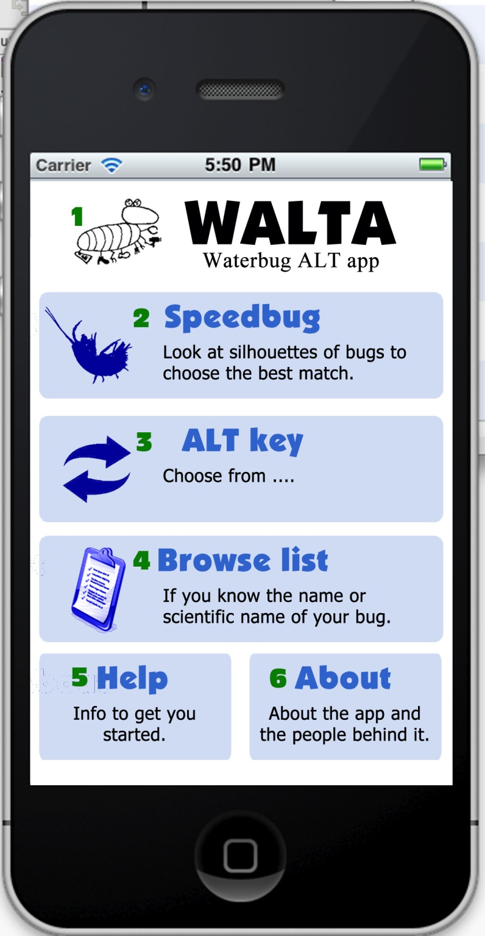

Entire blue section of each button is linked.

1. Walta logo. No link intended at this time, but it could also go to the about section.
2. Speedbug. Not in use in stage one.
3. ALT key - starts the ALT section off (see page 3)
4. Browse list. Not in use in stage one.
5. Help - goes to
6. glossary of terms and icons
7. more stuff
8. About - goes to
9. Waterbug company info
10. contact details
11. Build number

ALT key in progress

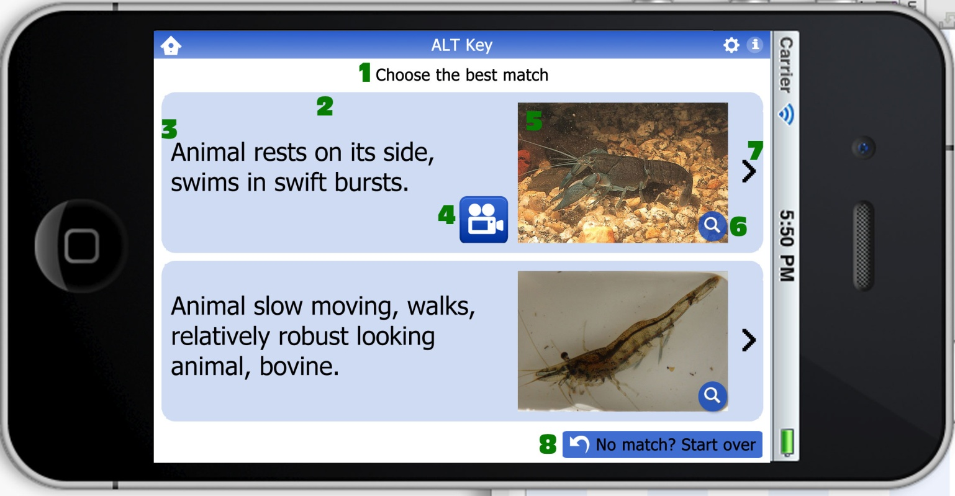**Description:** Main screen for the app. This is the screen that the home button goes back to. Entire blue area of each section is linked.

1. Page heading - centered
2. Section background - whole blue section is a hot key to the next section
3. Description - Aligned left, vertically aligned to the centre of the blue box.
4. Video icon - will only show up if video is available
5. Image - will only show up if image is available
6. Magnify link - whole image, including magnify button, will link to larger version of image (and full gallery if other images are available - see page 4)
7. Right arrow - indicates that there is a next section. Also linked, along with rest of blue section.
8. Start again button - takes you back to start of ALT section.

ALT key gallery

**Description:** What happens when you tap on the magnify link on an image. Tap on the images again to return to previous page.

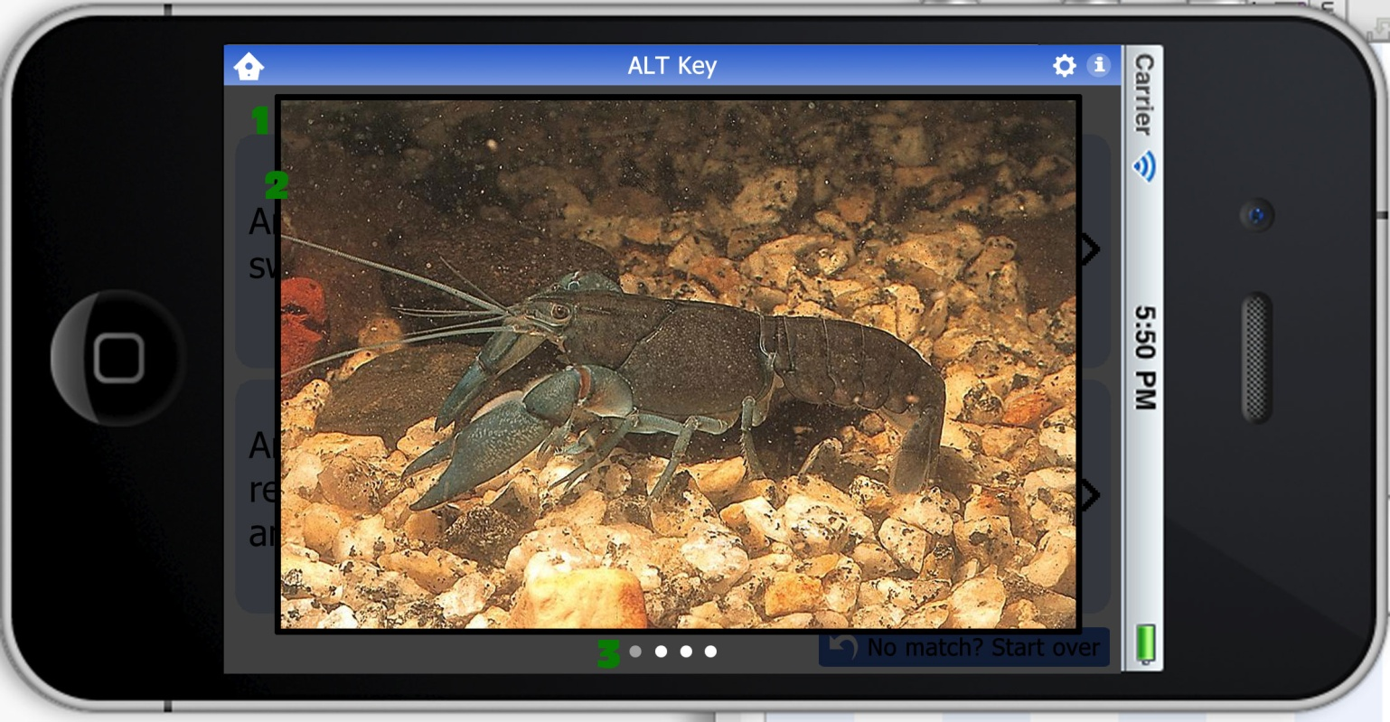

1. Large version of image opens in overlay. Background is greyed out to make it more visible.
2. Thick black border around image
3. Dots indicate how many images in gallery. Grey dot indicates which image you are viewing.

ALT key final screen

**Description:** The final results screen of the ALT section.

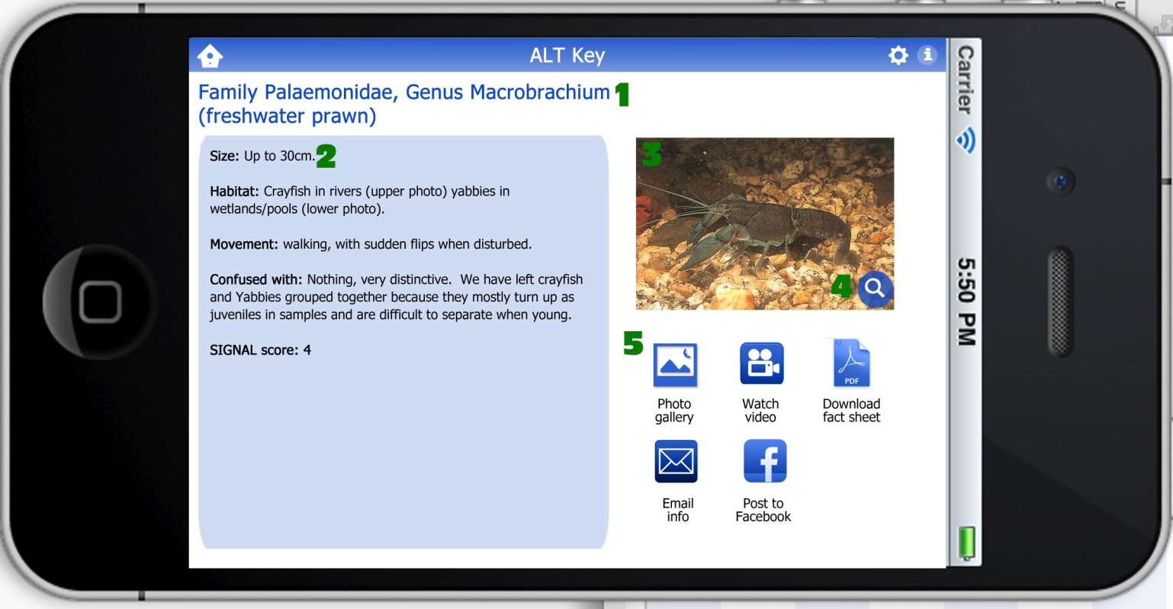

1. Heading - Name & scientificy bug name. Blue (#2f61cc). Left aligned.
2. Description - info about the bug.
3. Image - will only show up if image is available
4. Magnify link - whole image, including magnify button, will link to larger version of image (and full gallery if other images are available) - see page 5
5. Icons - should align to left and fall to next line if available.
6. Photo gallery - does same as magnify link above (item 3)
7. Video icon - only appears if video is present
8. Fact sheet - save PDF file of info
9. Email icon - email info to yourself or others
10. Facebook - put in just to annoy John